Montessori School of Central Marin

**2019-2020 APPLICATION FOR ENROLLMENT**

317 Auburn Street, San Rafael, CA 94901 (415) 456-1748 Web: montessoricentralmarin.org

Director: Doris Barbieri

Dear Parents,

We would like to thank you for trusting your child’s education to us. We feel honored to be part of your child’s upbringing and cherish this experience deeply. We also wish to welcome you to the upcoming 2019-2020 school year at Montessori School of Central Marin, which will begin on Tuesday, August 27th.

As the school year approaches, there are forms that need to be on file prior to your child’s attendance. The completion of the forms found in the Enrollment Package are both a licensing requirement of the State of California as well as Montessori School of Central Marin policy and must be on file in order for your child to attend.

The $500 non-refundable deposit used to secure your child’s placement will be applied towards your child’s tuition. This deposit will be deducted from either your last tuition installment for the 2019-2020 school year on May 1, 2020 or on September 1, 2019 if tuition is given in one payment.

The following forms, included in this package, need to be completed and returned at least 30 days prior to your child’s first day of attendance.

____ Application for Enrollment (2 pages)

____ Admission Agreement

____ Identification and Emergency Information Form

____ Child’s Preadmission Health History – Parent’s Report

____ Physician’s Report (2 pages)

____ Immunization Record*

____ Personal Rights Form

____ Notification of Parent’s Rights

____ Consent for Emergency Medical Treatment

____ Peanut & Nut Free School Acknowledgment

____ Full Signature Acknowledgement: Sign-In/Sign-Out Policy

____ Parent Participation Form

____ Acknowledgment of Parent Handbook

____ Blue Emergency Card

\**Immunization Record due after June 5th as Immunization Records are only valid for one year*.

Please let me know if you have any questions.

Sincerely,

Doris Barbieri

Montessori School of Central Marin

**2019-2020 APPLICATION FOR ENROLLMENT**

317 Auburn Street, San Rafael, CA 94901 (415) 456-1748 Web: montessoricentralmarin.org

Director: Doris Barbieri

**I hereby request space for my child for the program specified below. I enclose a non-refundable application fee of $100 and a tuition deposit of $500, which will be applied to the last tuition payment for the 2019-20 school year.**

Child’s Name: _______________________________ Age: _____ Birthdate: _______________

Place of Birth:_____________________ Race/Ethnicity:_______________ Gender: __________

**PROGRAMS FOR THE 2019-2020 SCHOOL YEAR**

August 27, 2019 to June 5, 2020

Half Day (3 hours) 9:00 am – 12:00 pm 12:00 pm – 3:00 pm

Extended Day (6 hours) 9:00 am – 3:00pm 12:00 pm – 6:00 pm

Daycare (full day) □ 7:00 am – 6:00 pm

Number of Days Per Week □ 2 Days (T-Th) □ 3 Days (M-W-F) □ 5 Days

**When would you like your child to start at MSCM?**

□ Fall Term (Aug 27th start) □ Spring Term (Jan 6th start) □ Other: ___________________

If we are unable to accommodate your child for the term and/or program you requested, would you like to remain on the waitlist until a space becomes available? Yes □ No □

I wish to pay tuition in: **□** 9 monthly installments (Sep – May) □ 1 installment (due Sept 1)

Parent’s Name:___________________________________________________________________

Relation to Child: _________________________ Occupation: ___________________________

Address: ________________________________________________________ Zip: ____________

Day Phone: ______________________________ Cell Phone: ______________________________

Email Address: ____________________________________________________________________

Parent’s Name:___________________________________________________________________

Relation to Child: _________________________ Occupation: ___________________________

Address: ________________________________________________________ Zip: ____________

Day Phone: ______________________________ Cell Phone: ______________________________

Email Address: ____________________________________________________________________

Parent/Guardian Signature: __________________________________________________________Date: _________________

*To be completed by Director: Date Received: ________ Deposit _________* *Enrollment Package □ Room No_____*

Montessori School of Central Marin

**2019-2020 APPLICATION FOR ENROLLMENT**

Child’s Name: __________________________ Birthdate:___________________________

**Childcare History:**

Has your child attended a childcare environment out of your home? Yes □ No □

Full time or part time? _____________ How many children at program/care center? ______________

Has your child been in the care of a nanny or caretaker other than family before? Yes □ No □

**Nap Time:**

Does your child nap at home? Yes □ No □ If yes, for how long? _________________________________

Please indicate if your child uses any of the following for comfort, while taking a nap?

□ pacifier □ bottle □ sippy cup □ blanket □ lovey □ other: _______________________

Has your child napped away from home/parents before? Yes □ No □

**Lunch and Snack Time:**

Does your child have food allergies? Yes □ No □ Is this allergy life threatening? Yes □ No □

If yes, please describe: ____________________________________________________________________

Does your child have any dietary restrictions? Yes □ No □

Vegetarian? Yes □ No □ Vegan? Yes □ No □ □ other: __________________________________

Does your child use any of the following at meal time?

Fork or spoon? Yes □ No □ High chair? Yes □ No □ A cup? With lid □ without lid □

**Potty Habits:**

Does your child wear diapers/pull ups? Yes □ No □ Other:_____________________________________

Does your child use a potty chair or adult toilet? ______________________________________________

If your child is potty trained, does he/she need a pull-up/diaper at nap? Yes □ _____________ No □

**Your Child:**

Please give us a brief description of your child to help us become familiar with his/her: Is there anything we should know about your child? Ex: likes/dislikes, does he/she put things in their mouth, any fears (people, noises, etc.), behavior when upset, and any other thoughts or concerns for the coming year?

_________________________________________________________________________________

_________________________________________________________________________________

_________________________________________________________________________________

_________________________________________________________________________________

_________________________________________________________________________________

_________________________________________________________________________________

_________________________________________________________________________________

_________________________________________________________________________________

Montessori School of Central Marin

2019 – 2020 CALENDAR

|  |  |
| --- | --- |
| August 21 | Welcome-to-School Orientation, 10:00 am to 12:00 pm – For children & in their parents in the 3 days per week program or 5 day per week program* |
| August 22 | Welcome-to-School Orientation, 10:00 am to 12:00 pm – For children & their parents in the 2 days per week program or 5 day per week program* |
|  | *\*Children enrolled in the 5 day per week program may attend the* Back-to-School Orientation *either Aug 21 or 22, the same information will be shared both days.* |
| August 26 | **Teacher Work Day: No School/No Daycare** |
| August 27 | **First Day of School** |
|  |  |
| September 2 | **Labor Day: No School/No Daycare** |
| September 4 | Back to School Night Orientation: 7:00 – 8:00 pm Adults only |
| September 13 | Potluck: 6:00 – 8:00 pm, Adults & Children |
| 0 |  |
| October 14 | **Teacher Work Day: No School/No Daycare** |
| October 19 | Work Party (Volunteer Opportunity): 9:00 am – Noon |
| October 23 | Parent Education: Montessori in the Classroom 5:00 – 6:00 pm |
| October 31 | Halloween Parade & Party: 10:00 am |
|  |  |
| November 1-29 | Parent Observation Days |
| November 11 | **Veterans Day Observed: No School/No Daycare** |
| November 13 | Picture Day |
| November 13 | Parent Education: *Positive Discipline (Part I)* 5:00 pm – 6:00 pm |
| November 14 | Picture Day Make Up Day |
| November 27 | Thanksgiving Potluck Luncheon, 12:00 – 12:30 pm |
| November 28-29 | **Thanksgiving: No School/No Daycare** |
|  |  |
| December 5-6 | Scholastic Book Fair |
| December 6 | Parent Conferences: No School/Day Care Available |
| December 19 | Winter Concert & Potluck: 6:00 pm – 8:00 pm |
| December 20 | **Teacher Work Day: No School/No Daycare** |
| December 23 – January 3 | **Winter Break**: **No School/No Daycare December** **23**, **24, 25, 31 and January 1** |
|  | No School/Daycare Available December 26, 27, 30 and January 2, 3 |
|  |  |
| January 6 | First Day of School after Winter Break |
| January 20 | **Martin Luther King Jr. Day: No School/No Daycare** |
| January 22 | Fathers’ or Special Friends’ Night: 5:00 pm – 6:00 pm |
| TBA | Vision Screening: 9:00 am |
|  |  |
| February 5 | Parent Education: *Positive Discipline (Part II)* 5:00 pm – 6:00 pm |
| February 14 | Valentine’s Day Party: 10:00 am – 11:00 am |
| February 17 & 21 | **Presidents’ Days: No School/No Daycare** |
|  |  |
| March 4 | Parent Education: *Montessori in the Home* 5:00 pm – 6:00 pm |
| March 7 | Family Gardening Day: 9:00 am- 12:00 pm |
| March 17 | St. Patrick’s Day Luncheon: 12:00 pm – 12:30 pm |
|  |  |
| April 3 | Egg Hunt: 10:45 am - *Children only* |
| April 1–30 | Parent Observation Days |
| April 2-10 | Scholastic Book Fair |
| April 6-10 | **Spring Break:** No School/ Daycare Available |
| April 25 | Volunteer Work Day: 9:00 am – 1:00 pm |
|  |  |
| May 1 | **Parent Conference: No School/Daycare Available** |
| May 8 | Mother’s Tea: 3:00 pm |
| May 25 | **Memorial Day: No School/No Daycare** |
|  |  |
| June 4 | Graduation & International Potluck: 6:00pm – 8:30 pm |
| June 5 | **Last Day of School:** Pajama Day |
| June 8 | **Teacher Work Day: No School/No Daycare** |
|  |  |
|  |  |

Note: Fun Lunch is served on Tuesdays and Thursdays

Sharing day is every Wednesday, please refer to the monthly calendar for the corresponding letter of the week.

(Dates subject to change with two weeks notice)

Revised 1/2/2019

Montessori School of Central Marin

**2019-2020 APPLICATION FOR ENROLLMENT: TUITON PAYMENT INFORMATION**

317 Auburn Street, San Rafael, CA 94901 (415) 456-1748 Web: montessoricentralmarin.org

Director: Doris Barbieri

Montessori School of Central Marin offers the following 2 payment plans and sibling discount:

|  |  |  |
| --- | --- | --- |
| **PLAN TYPE** | **PAYMENT SCHEDULE** | **PLAN DESCRIPTION** |
| **Plan A** | In Full | Payment (tuition and books/materials fee) is due by September 1st, 2019. A 5% discount is offered to those who elect to pay tuition in full. |
| **Plan B** | 9 Monthly Payments | Beginning in September 1st 2019, nine (9) monthly payments will be due on the 1st of each month through May 2020. The books and materials fee is due with the September payment. |
| **Sibling Discount** | | A sibling discount of 10% can be deducted from the eldest child’s tuition. |

Details Regarding Payment Plan B:

In order to assist you with the amount due each month with tuition plan B, you will receive a monthly invoice from our online communication and payment platform, Curacubby.

For tuition plan B, tuition is due on the 1st of each month with a 5 day grace period. After the 5th of each month, a $25 late fee will be assessed.

Additional Considerations:

The parent/guardian(s) signing the Student Enrollment Agreement is/are solely responsible for payment of tuition, fees, and all incidental charges. The School will not attempt to collect payment from any other source(s).

You may also receive a monthly invoice for any incidental fees (daycare hours, late charges, etc.) you have incurred at the beginning of each month.

Deposit Policy:

Please note, the $500 non-refundable deposit used to secure your child’s placement will be applied towards your child’s tuition for the 2019-2020 school year.

**• Plan A:** The deposit will be deducted from the one tuition payment due on September 1, 2019.

**• Plan B:** This deposit will be deducted from your last tuition installment for the 2019-2020 school year on May 1, 2020.

Montessori School of Central Marin

**2019-2020 APPLICATION FOR ENROLLMENT: TUITON**

**2019-2020 School Year Tuition**

**Tuesday, August 27, 2019 to June 5, 2020**

**Toddler Program (2-3 years old Books and Materials Fee**

**Half Day: 9:00 am – 12:00 pm or 12:00 pm – 3:00 pm**

**5 Days: $12,500 $200**

**3 Days: $9,200 $150**

**2 Days: $7,000 $100**

**Extended Day: 9:00 am – 3:00 pm or 12:00 pm or 6:00 pm**

**5 Days: $15,300 $200**

**3 Days: $11,000 $150**

**2 Days: $9,500 $100**

**Day Care: 7:00 am – 6:00 pm (school in session from 9:00 am – 3:00 pm)**

**5 Days: $17,500 $200**

**3 Days: $12,800 $150**

**2 Days: $10,600 $100**

**Preschool Program (3-5 years old) Books and Materials Fee**

**Half Day: 9:00 am – 12:00 pm or 12:00 pm – 3:00 pm**

**5 Days: $12,200 $200**

**3 Days: $9,000 $150**

**2 Days: $6,800 $100**

**Extended Day: 9:00 am – 3:00 pm or 12:00 pm – 6:00 pm**

**5 Days: $15,000 $200**

**3 Days: $10,800 $150**

**2 Days: $9,300 $100**

**Day Care: 7:00 am – 6:00 pm (school in session from 9:00 am – 3:00 pm)**

**5 Days: $17,200 $200**

**3 Days: $12,600 $150**

**2 Days: $10,400 $100**

**Sibling Discount………………………………………………………………………………….…….…. 10 % deducted from Eldest Sibling’s Tuition**

*MC3: We accept the weekly payment schedule from Marin Child Care Council*

**Other Fees for the 2019-2020 School Year**

**Application Fee (Due with application; non-refundable) ……………………………………………..…..……………….................. $100**

**Deposit (Applied to 2019-2020 tuition) …….………………………….………………………………………………………….……………………….. $500**

**Books and Materials Fee (Based on program)…………………………………………………………………………..……….due on September 1st**

**Volunteer Commitment – Commitment of eight hours per child or twelve hours for two or more children, per year,**

**or a payment of $160 per child for those who cannot fulfill the volunteer commitment.**

**Fees Billed Monthly**

**Day Care Charges ………………………………………………………………………………………………..……………………………………………..$12.00 /hour**

**Late Pick Up (after 6:00 pm) ………………………………………………………………………………………..……………………………….. $5/5 minutes**

**Late Payment Fee …………………..…………………………………………………………………………………..………………………………………………… $25**

Montessori School of Central Marin**ADMISSION AGREEMENT**

**PLEASE READ AND INITIAL EACH STATEMENT**

**CHILD’S NAME: __________________________________ BIRTHDATE: _______________**

I grant permission for my child to use all the play equipment and to participate in all school activities. ________

I grant permission for the school to publish my child’s picture for MSCM’s promotional purposes.

Yes □ No □ ________

I grant permission for the school to share my family’s contact information (email and phone number) with other MSCM families through the Family Directory to facilitate contact with other families.

Yes □ No □ ________

I grant permission for my child to leave the premises under the supervision of a staff member for scheduled field trips in an authorized vehicle. I am aware that I will be notified at least one (1) week in advance and that a signed permission form is required for each excursion. ________

I have received and read the PARENT HANDBOOK and understand that it is part of the ADMISSION AGREEMENT. I agree to comply with the rules concerning admittance, attendance, sick children, arrivals and departures, drop-off and pick-up times, absences, finances, parent involvement, and all other items specified. ________

I grant permission for the school to take whatever steps may be necessary to obtain emergency medical care as specified in the PARENT HANDBOOK. I have completed a BLUE EMERGENCY CARD and agree to inform the school immediately of any changes in the information contained on the card. ________

I am aware that my child must be SIGNED-IN UPON ARRIVAL AND SIGNED-OUT UPON DEPARTURE BY AN AUTHORIZED ADULT. Failure to do so will result in charges being assessed. I understand that I have the right to visit and observe the school at any time my child is in attendance. ________

I understand the licensing agency, California State Department of Social Services, shall have the authority to interview clients, and to inspect client or facility records without prior consent. The agency shall have the authority to observe the physical condition of clients, including conditions which could indicate abuse, neglect, or inappropriate placement. I understand that I have the right to call or write the licensing agency if fault is found in the operation of the facility or the treatment of my child. ________

I agree to notify the school 30 days in advance of withdrawal or pay the difference. The school retains the right to terminate enrollment in the event of non-compliance with school policies, rules, or regulations. ________

I am aware of scheduled holidays and no school/daycare only days. ________

I have received a current tuition schedule and agree to comply with all stated rules regarding fee, finances, and tuition. I understand that no basic rate or policy changes will take place without at least 30 days written notice.

________

I understand tuition for my child for the 2019-2020 school year is $ ____________. ________

I understand the Materials/Books Fee for the 2019-2020 school year is $__________. ________

*This fee is due in full with the first tuition installment.*

I understand that my child’s tuition is due on the 1st of each month with a grace period until the 5th of the month and that failure to pay tuition and/or the materials/books fee by the due dates may result in a late charge ($25 late fee) and/or my child being suspended from the school. I also understand that in the event my child is suspended, a tuition deposit may be requested for readmission. ________

*I understand that my signature on this form constitutes a contractual agreement.*

Parent Signature: ______________________________________________________ Date: ______________________

Macintosh HD:Users:Montessori:Desktop:Identification and Emergency Contact Form.pdf

Macintosh HD:Users:Montessori:Desktop:Pre-Admission Health Form.pdf

Macintosh HD:Users:Montessori:Desktop:Physicians Report.pdf

Macintosh HD:Users:Montessori:Desktop:Physicians Report pg 2.pdf

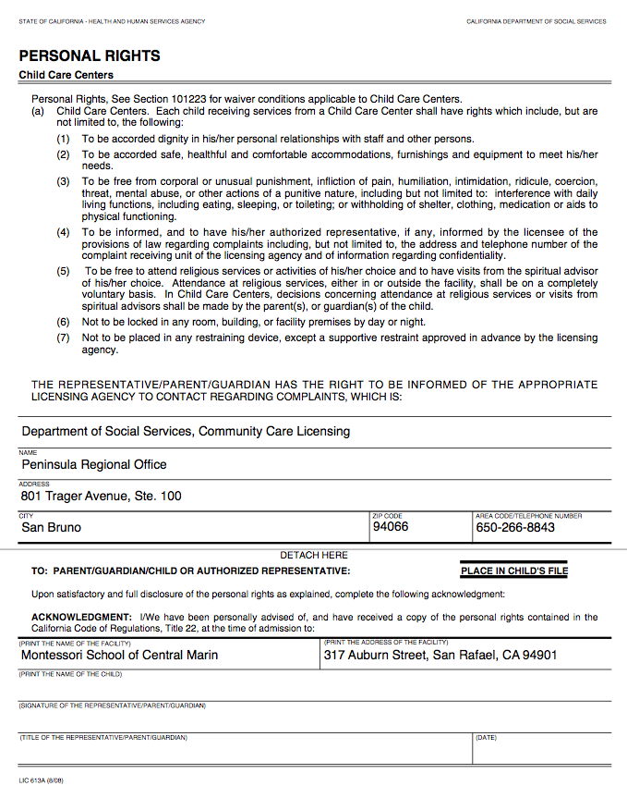

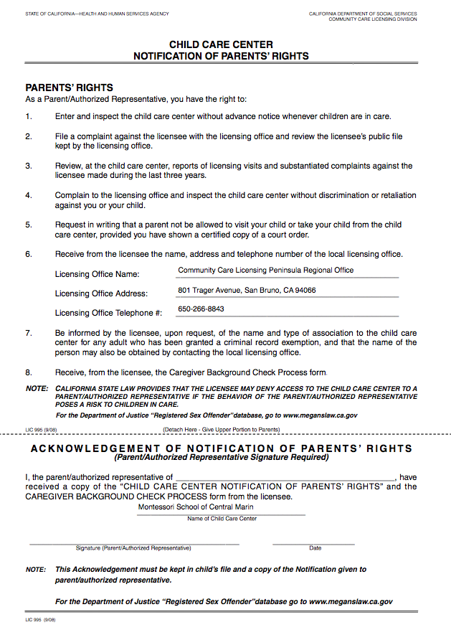

Macintosh HD:Users:Montessori:Desktop:Consent For Emergency Medical Treatment.pdf

Montessori School of Central Marin

**2019-2020 APPLICATION FOR ENROLLMENT**

**PEANUT & NUT FREE SCHOOL ACKNOWLEDGMENT**

Dear Parents,

This letter is to inform you that there will be children with severe food allergies to peanuts and tree nuts during the 2019-2020 school year. Nuts include, but are not limited to: walnut, almond, hazelnut, cashew, pistachio, pecan, and brazil nuts. In order to avoid any risk, the entire school will be completely nut-free and peanut-free for the 2019 - 2020 school year.

It is important that there is strict avoidance of these foods in order to prevent a life-threatening allergic reaction. We are asking your help to provide all our children with a safe school environment.

Please know that any exposure to peanuts and nuts may cause a life-threatening allergic reaction that requires emergency medical treatment. **To reduce the chance of this occurring, we are asking that you do not send any peanut or nut containing products to school with your child that will be eaten in the classroom or that will be shared during birthday celebrations and school gatherings.**

If your child has eaten peanuts or nuts before coming to school please be sure your child’s hands and face have been thoroughly washed with soap & water before entering the school.

We appreciate your support of these procedures. Kindly complete and return the bottom portion of this form so we are certain that you have reviewed this information.

Please contact me if you have any questions. Thank you very much for keeping all of our students healthy and safe for the upcoming school year.

Sincerely,

Doris Barbieri

Director

-------------------------------------------------------------------------------------------------

**2019-2020 Food Allergy Acknowledgement**

I have read and understand MSCM’s Peanut and Nut Free School policy. I agree to do my part in keeping the school peanut and nut free.

Child(ren)’s Name(s): ___________________________________________________________

Parent’s Name: _______________________ Parent’s Signature __________________________

Date ________________________________

Montessori School of Central Marin

**2019-2020 APPLICATION FOR ENROLLMENT**

**Full Signature Acknowledgement: Sign-In/Sign-out Policy**

The State of California, Health and Human Services Agency, Department of Social Services require that a parent or authorized representative sign their child in and out each with a full signature. Initials are not acceptable.

*101229.1 Sign In and Sign Out*

*(a) In addition to the sign-in procedure requirement of Section 101226.1 (b), the licensee shall develop, maintain and implement a written procedure to sign the child in/out of the School that shall, at the minimum, including the following:*

*(2) The person who signs the child in/out shall use his/her full legal signature and shall record the time of day.*

*(b) The person who brings the child to, and removes the child from, the School shall sign*

*the child in/out.*

*(c) A person who removes the child from the School during the day, and returns the*

*child to the School the same day, shall sign the child in/out.*

Community Care Licensing review facility records during their visits. At the time of the visit, the Sign-In/Sign-Out logs are also reviewed. If it is found that parents are not properly signing-in/signing-out their children, a deficiency notice is given to the Center. Civil Penalties of $50.00 per day are assessed if violations continue after the citation date. Should our School be fined by Licensing for a violation of this regulation, the appropriate amount of the fine will be billed to the violating parent.

**Child’s Name:** ___________________________________________________________________

**Parent/Authorized Representative Name**: ___________________________________________

**Parent/Authorized Representative Signature:** ________________________________________

**Date:** __________________________

Montessori School of Central Marin

**2019-2020 APPLICATION FOR ENROLLMENT**

**Parent Participation Form**

**CHILD’S NAME: ___________________________________**

**PARENT’S NAME: __________________________________**

Each family, as part of this school community is required to give eight hours of time for one child or twelve hours for two children per school year. The following is a list of activities that can be used toward your commitment. With the exception of fieldtrips, all other activities are worth the time given. Please complete the form below and return.

___ Chaperone/Driver for Field Trips (credit hours equal to field trip length)

___ Room Parent

___ Classroom Presentations (cultural, religious holidays, or other topic relating to

curriculum)

___ Chair Committee Positions (please see board for details regarding positions)

___ Setup for School Events

___ Classroom Materials – minor construction and/or restoration

___ Carpentry – small repairs

___ Saturday work parties: playground/outdoor maintenance (gardening, minor repairs)

___ Landscaping

If you are unable to make the volunteer commitment due to time restraints, then a charge of $160, or the prorated amount, is applied at the end of the school year.

______________________________________________________ _______________________

Parent Signature Date

Montessori School of Central Marin

**2019-2020 APPLICATION FOR ENROLLMENT**

**Acknowledgement of Receipt of Family Handbook**

Acknowledgement of Receipt of Family Handbook

Dear Parent(s)/Guardian(s):

Please read and sign this agreement.

I hereby acknowledge that I have received the FAMILY HANDBOOK. I hereby agree to uphold the rules and regulation of the MONTESSORI SCHOOL OF CENTRAL MARIN as spelled out in the FAMILY HANDBOOK.

____________________________________________ ________________

Signature of Parent or Guardian Date